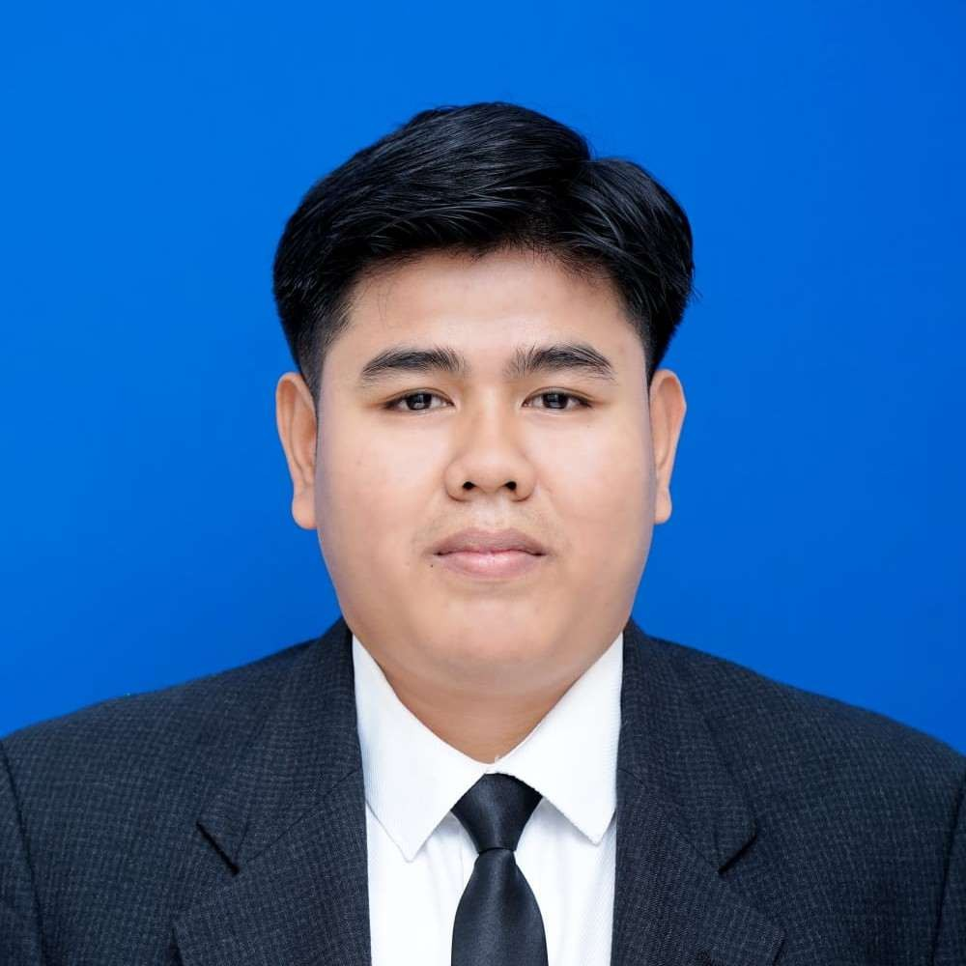
REZA SEPDIDE
Civil Engineering Graduate | Quantity Surveyor & Construction Planner | BIM & CAD Modeler
Padang, West Sumatra, Indonesia | +62 896-4459-0915 | rezasepdide@gmail.com
LinkedIn: linkedin.com/in/rezasepdide

PROFESSIONAL SUMMARY

Associate Degree (Diploma III) graduate in Civil Engineering from Politeknik Negeri Padang (GPA 3.72/4.00) holding a BNSP Certification as Implementing Intermediate Building Construction (Level 5) with a proven track record in technical building planning, Quantity Surveying (QS), and construction quality and schedule control. Experienced in preparing Detailed Engineering Designs (DED), Bills of Quantities and Cost Estimates (RAB), Work Plans and Technical Specifications (RKS), and project schedules (S-Curve). Proficient in operating modeling and construction management software including Autodesk Revit (BIM), AutoCAD, SketchUp, SAP2000, Microsoft Project, and Microsoft Excel, coupled with certified language communication skills in Japanese and English.

WORK EXPERIENCE

Technical Planner (Elementary School Revitalization Planning Consultant) Sep 2026
SDN 19 Kuamang Revitalization Project Pasaman, Indonesia
- Calculated bill of quantities and prepared Cost Estimates (RAB) for the revitalization of school facilities.
- Drafted Work Plans and Technical Specifications (RKS) as technical guidelines and quality standards for on-site construction materials.
- Formulated the project Time Schedule and plotted project weights into an S-Curve.
- Produced architectural and structural working drawings (Detailed Engineering Design/DED) for the school building using AutoCAD.

Technical Planner (Special Needs School Revitalization Planning Consultant) Jul 2026
SLBN 2 Pariaman Revitalization Project Pariaman, Indonesia
- Calculated bill of quantities and prepared Cost Estimates (RAB) for the revitalization of school facilities.
- Drafted Work Plans and Technical Specifications (RKS) as technical guidelines and quality standards for on-site construction materials.
- Formulated the project Time Schedule and plotted project weights into an S-Curve.
- Produced architectural and structural working drawings (Detailed Engineering Design/DED) for the school building using AutoCAD.
- Generated Contract Change Orders (CCO) for design modifications from the initial contract.
Quantity Surveyor (Freelance) Sep 2025

PT Mulia Djasmine Sentosa — Subcontractor for PT Perfetti Van Melle Indonesia Project
- Executed recalculations of work quantities based on actual site conditions (MC-100).
- Prepared cost recapitulations and valuation of work based on verified actual quantities as the baseline for subcontractor payment claim submissions.
- Generated Contract Change Orders (CCO) for new item from the initial contract.
Technical Facilitator — Primary School Revitalization Program Jun 2025 – Dec 2025

Ministry of Primary and Secondary Education (Kemendikdasmen)
- Reviewed and evaluated the feasibility of administrative and technical planning documents (Detailed Engineering Design/DED, RAB, and RKS) of beneficiary schools.
- Conducted periodic monitoring and evaluation of physical progress on-site to ensure alignment with approved schedules and quality standards.
- Verified the completeness and validity of work progress reports as a prerequisite for government grant installment disbursements.

Field Intern Aug 2024 – Dec 2024

PT Solusi Industri Energi — Contractor for Waste Gas Recovery Project (PT Indo-Bharat Rayon) Purwakarta, Indonesia
- Prepared Bar Bending Schedules (BBS).
- Calculated installed work volumes (Backup Volume) as supporting documentation for progress billings.
- Performed on-site Quality Control (QC) inspections, including Slump Tests for fresh concrete, pre-pour reinforcement placement verifications, and completing inspection checklists.
- Executed site mapping and compiled Punch Lists before and after workspace handover.
- Prepared daily, weekly, and monthly progress reports to support project management coordination.

EDUCATION

Politeknik Negeri Padang Aug 2026 – Present

Bachelor of Applied Science (D4) in Construction Engineering and Management Padang, Indonesia
Politeknik Negeri Padang Sep 2022 – Jul 2025
Associate Degree (D3) in Civil Engineering | GPA: 3.72 / 4.00 Padang, Indonesia
- Final Project : Estimated Cost Budgets (RAB) and developed project schedules (Time Schedule) for the case study “Construction Implementation Plan for the Regional House of Representatives (DPRD) Building of Pasaman Regency”.
- National Tender Competition “Fondasi Days 2025” (Universitas Sebelas Maret) : Participated in preparing tender bid proposals, 3D construction modeling using SketchUp, analyzing technical construction methods, and estimating project costs.
- Student Creativity Program – Scientific Article (PKM-AI) Kemendikbudristek : Authored a scientific paper titled “Scaffolding Cost Analysis on the Waste Gas Recovery Project of IBR Purwakarta”, evaluating cost efficiency between scaffolding purchase and rental schemes.
- Building Design Pre-Project : Conducted 3D structural modeling and load analysis for multi-story buildings using SAP2000 software.
SMA Negeri 1 Padang 2019 – 2022
Sciences Major Padang, Indonesia

PROFESSIONAL CERTIFICATIONS & LICENSES

- Work Competency Certificate for Implementing Intermediate Building Works (Level 5) — Badan Nasional Sertifikasi Profesi (BNSP) — Organized by the Ministry of Public Works, Construction Services Center Region I Banda Aceh.
- Certificate of Completion: Revit Masterclass for Beginners (Building Information Modeling) — Arsisten Academy.
- Specified Skilled Worker (SSW) Evaluation Exam for Construction Industry — Japan Association for Construction Human Resources (JAC).
- Japan Foundation Test for Basic Japanese (JFT-Basic) & JLPT N4 — The Japan Foundation.
- Toeic Test — Politeknik Negeri Padang

SKILLS & COMPETENCIES

  - Hard Skills :
    - Quantity Take-Off & Cost Estimation (RAB)
    - Preparation of Technical Specifications (RKS)
    - Project Scheduling (Time Schedule & S-Curve)
    - Bar Bending Schedule (BBS)
    - Detailed Engineering Design (DED)
  - Soft Skills :
    - Hardworking
    - Fast Adaptability
    - Responsible
    - Team Collaboration
  - Software Skills :
    - Autodesk Revit (BIM)
    - AutoCAD
    - SketchUp
    - Microsoft Excel
    - Microsoft Project
    - SAP2000
  - Language Proficiencies :
    - Indonesian (Native)
    - Japanese (Intermediate: JFT-Basic Score 250 and JLPT N4 Score 165)
    - English (Intermediate: TOEIC Score 640)

